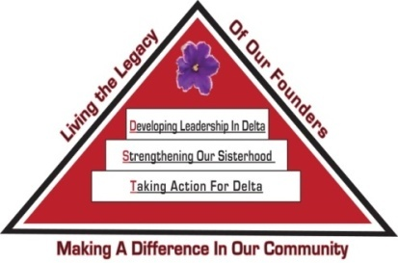 Tampa Alumnae Chapter
Delta Sigma Theta Sorority, Inc.
2nd Vice President Report
January 2020

Archives
- Chair: Soror Tonja Brickhouse tbrick4140@aol.com Properties/Storage sub-committee - Co-chair, Soror Schantel Bobo, tcbfl2000@aol.com
The committee is looking for sorors to share the “Top 2” things they would like the Archives Committee to achieve this year. Please email your feedback.
If you are a past president of Tampa Alumnae, the committee would like you to send your bio to tbrick4140@aol.com by January 18. Feel free to contact Soror Brickhouse with any questions.

Nominating Committee
- Chair: Soror DeVonne McKeever-Daniels devonnemc9@gmail.com Co-Chair: Alicia Howell-Banks achowell75@yahoo.com
Report submitted separately.

Grants
- Chair: Soror Tina Fernandez, tfernandez35@gmail.com
No report at this time.

Membership Services
- Chair: Soror TeKeisha Zimmerman Zimmerman.tekeisha@gmail.com
Concerns
- Co-Chair: Soror Wanda Seigler poppye53@gmail.com
Courtesy
- Co-Chair: Soror Leslie Woods-Brown, drbrown427@verizon.net
Delta Connection
- Co-Chair: Soror Theresa Cross tcross499@gmail.com
Hospitality
- Co-Chair: Soror Alicia Howell Banks achowell75@yahoo.com
Orders for DSTTA nametags will be taken during December and January chapter meetings.
Social
- Co-Chairs: Soror Jacquelyn Bogen yvonne33617@yahoo.com, Soror Chantelle Harrison chantelle.harrison9@gmail.com
Please contact the sub-committee immediately to notify them of any events you anticipate using their services throughout the sororal year.
Delta Internal Development
- Co-Chair: Soror Nadine Johnson, njdelta40@aol.com
Collegiate Connection
- Co-Chair: Soror Jasmine White-Bynum, jswhiteb@ncsu.edu
Collegiate Connection Month is in February. The sub-committee is planning a special TA101 session for our collegiate as well as a social opportunity. More details to come.
Reclamation
- Co-Chairs: Soror Estella Gray estellagray@yahoo.com
Founders Day
- Co-chair: Soror Edith Randolph edithrandolph27@yahoo.com

Happy Founders Day Sorors!
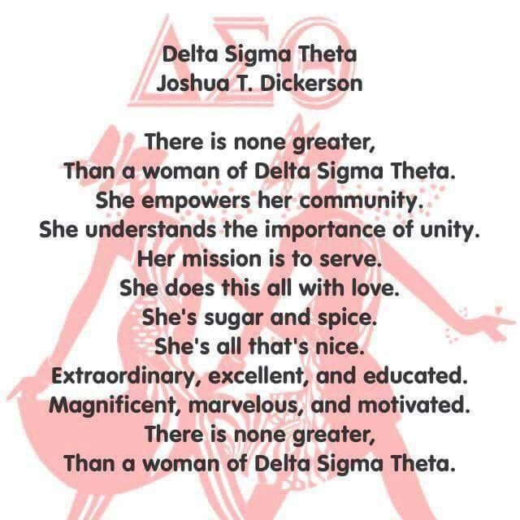

Technology and Communications Committee
- Chair: Soror Katina Robinson ebonykat@tampabay.rr.com Co-chair –Soror Dioan Johnson, djatlast1913@gmail.com
No report at this time.

Ritual and Ceremonies
- Chair: Soror Janice Crowley crowleyj002@yahoo.com, Soror Joyce Patterson patsjoy127@yahoo.com
No report at this time.

Public Relations
- Chair: Soror Jamel Lanee jlanee1@gmail.com, Co-Chair: Soror Mallory Davis mal.davis1913@gmail.com
The committee asks that requests for publicity be submitted 8 weeks prior to the event so there is ample time to create and implement an appropriate plan.

Policies and Procedures
- Co-Chair: Soror Tayanna Richardson tqsarichardson@yahoo.com
Proposed changes to chapter policies and procedures will be due in February. Please review the current chapter policies and procedures for understanding prior to suggesting changes and for information on the P&P update process.

Protocol and Traditions
- Chair: Soror Imani Coles Imani.coles@spartans.ut.edu, Co-chair: Soror Marian Lauria-Gibson mslauria1@verizon.net
No report at this time.

Strategic Planning
- Chair: Karen Beard, Co-Chair: Tonja Brickhouse
No report at this time.

Audit
- Chair: Soror Gloria Williams glojean29@earthlink.net
No report at this time.

Respectfully Submitted,
Sabrina Griffith, 2nd Vice President

